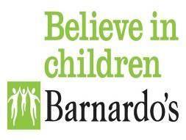
see, hear, respond
supporting information For Referal Partners

- Programme Overview
In response to the COVID-19 pandemic, Barnardo’s, in partnership with The Department for Education (DfE), will be delivering a new and innovative programme across England that co-ordinates a dynamic sector response. This will mean intervening and finding the most vulnerable children and young people who are hidden from view; who are not receiving support currently from statutory organisations and those who are at risk and/or experiencing adverse impact to their health and wellbeing.
Many of our most vulnerable children and young people are being missed and the harm that they experience is now hidden more than ever. Through a partnership approach we will support and safeguard these children early, preventing additional harm and ensuring that their needs don’t escalate to become chronic and persistent levels.
The children and young people that we will target, find and support during these unprecedented times will include the most vulnerable within our community. This will include:
- Under 5s with a specific focus on under 2s
- Those with SEND who have other associated harms such as exploitation
- Children out of the home at risk of criminal and sexual exploitation (working in outreach detached settings)
- BAMER children (who are not being seen or reached)
- Young carers
Barnardo’s is convening a network of national and local community-based partners to work together to identify and provide frontline support to these vulnerable children and young people. Our network of partners will mobilise rapidly and effectively to ensure that children are identified and supported as quickly as possible.
The See, Hear, Respond programme will not work with those currently receiving support from statutory agencies, for example through Child Protection Plans. Instead, we will target resources and support to fill the growing gap for those children who require support but are not being seen by schools or other key agencies. It is these children and young people who are being disproportionately adversely impacted by Covid-19 restrictions.

- Why refer and who’s eligible?

Firstly it is important to note that this service is not a substitute for existing statutory support. If you are concerned that a child is at risk of significant harm then a referral should be made to your usual Children’s Services safeguarding front door. If you feel a child is likely to need long term child in need support then a referral into your early help hub or child in need process is likely to be a more effective option.

This service is aimed at those children who are not receiving support, or who have not met thresholds but because of COVID-19 and wider problems are struggling and them and their families would benefit from some immediate help in the short term.

We want to direct support where it is needed the most and to touch base with those families that have disengaged from education, support services or whose usual support has stopped during this period.

The aim is to provide short term wrap around support to help de-escalate issues and support children with re-integration to education and agencies where their support needs can be met in the longer term. It is aimed at helping our statutory service partners manage during these difficult periods and filling local gaps where possible. There is however, always the likelihood that we will come across families whose levels of need and potential risk of harm is such that referrals into statutory services are necessary. We will work together to support children until these families can be picked up by the relevant services safely.

In addition to taking referrals for individual children and families – we will also operate an outreach and detached service – where referrals can be made into the intake hubs for a place or space where children are potentially at risk of harm and would benefit from engagement. For example a local park or shopping centre where children are congregating and where street based safeguarding conversations with trained youth workers would create a safer environment for all.

We will work closely with existing multi-agency forums across England to share progress of the service and key issues and patterns that are emerging from the work to help inform local authority recovery plans.

We have a Freephone number for children and families who wish to self-refer:

Free phone: 0800 157 7015

If you are a professional we would ask that you complete the secure online referral form that can be accessed here:

www.barnardos.org.uk/see-hear-respond

If you would like to talk to your local regional co-ordinator about any aspect of the programme their details can be found below.

Regional Coordinator  Kate Goodwin | Email/ Phone  Kate.goodwin@barnardos.org.uk  07876 190420

- Service Delivery Model
The See, Hear, Respond programme will deliver a three strand model across England. The programme has been developed to respond to children who are experiencing harm and increased adversity at a time where services are required to shape their response and approach to addressing new emerging need.
The delivery model will provide flexibility for delivery partners to adapt working practices to de-escalate the likelihood of harm and ensure other supports and protective networks are in place. It is not intended to provide funding for longer term recovery or socio-educative approaches, instead focusing on: crisis intervention to de-escalate issues of concern; emergency family support; brief therapy models and re-integration into wider forms of support.
The model contains the below key components:
Figure 1.0: See, Hear, Respond Programme - Service Delivery Model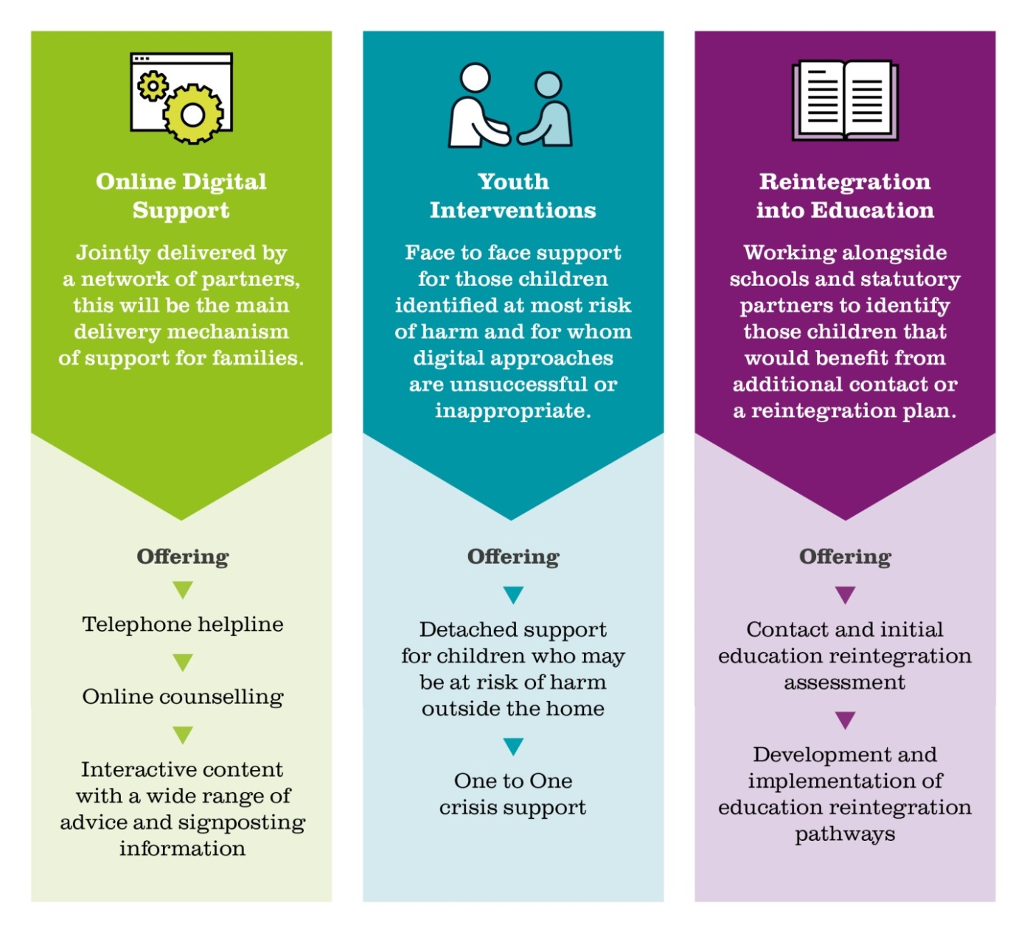

Accessing the Service

Intake Assessment and Outreach Teams located in London, the North, Central, South East and the South West of England will generate referrals by working with local partners including schools, health, statutory agencies and community groups to identify those children that agencies are most worried about and make assertive outreach contact with families. Each local intake team will develop a database of all partners, their offer and capacity to respond. All local partners will receive guidance around standards, and practice approaches and will be required to sign up and adhere to Barnardo’s safeguarding policies and procedures.
Initial assessments will identify children and their family’s primary and wider needs and support will be sourced from the most relevant agency to provide help through one of the following 3 key support delivery mechanisms.

Online Digital Support
We will draw together the group of partners to garner their online and digital technology to support children and families during Covid-19 and lockdown. It will be the main delivery mechanism of support for families, in-line with government guidance on social distancing.
Online digital support will provide families with practical and emotional support and advice about a range of issues via the following:
Advice & Support

- Digital support packages of helpful advice, and signposting information for children and families. Information will be easily accessible and interactive and can be provided through podcasts, video and simple written text. Families will be supported to access the right agencies and implement family coping and safety strategies.
- A local telephone helpline, delivered by the Intake Assessment Outreach Team, will provide a triage function. Children and families will be able to access a worker who will complete a more detailed assessment of need and co-ordinate a package of support that addresses those key needs. This will include sourcing further help and support either through this service (i.e digital or crisis face-to- face support) or through other services that families can be signposted to and supported to access.

Therapeutic Support

- Online counselling/therapy for those assessed as experiencing high levels of anxiety, trauma or other mental health issues that can be safely worked with digitally to help people self-regulate, develop coping strategies, establish wider support networks and manage feelings and behaviours during this period.

Group Support:

- Digital family support groups prioritised for SEND parents and new parents. Children and families are provided with peer support networks that promote social connection, shared coping strategies, increased support networks and practical advice and help.
All of these resources will be developed with different cultural groups in mind and adapted and translated as appropriately required.

Youth Interventions
This strand will provide face-to-face support for those children identified at most risk of harm and for whom digital approaches are unsuccessful or inappropriate. Although we recognise that the safest models of providing support to children at this time are through digital, distanced approaches there are some children and families for whom this is clearly not working or sufficient to support and safeguard. This strand of work focuses on two groups of children:
- Those non-compliant with lockdown who may be out of the home because they are having family difficulties, are unsafe at home, are being exploited outside of the home, are engaging in antisocial or criminal activity; or are bored and choosing to hang out with friends which may in itself increase both health and safety risks.
- Those children and families in crisis who may be experiencing harm, whose mental health is deteriorating and digital approaches are insufficient; where digital technology is not available in the home; where children are vulnerable and parents are avoiding engagement and support.
Detached Youth Work

- Street safeguarding assessments will be undertaken with young people not complying with lockdown (as identified by the police). These assessments will identify push and pull factors, patterns of where children are going and with whom, indications of risk or abuse and the development of safety plans and ongoing digital support
- Multi-agency interventions will be delivered in local exploitation hot-spots identified with police and local ROCUs. We will broker local services to deploy community based specialist teams to safeguard and disrupt the exploitation of vulnerable young people at risk of criminal or sexual exploitation or those in anti-social peer groups/known territorial ‘gangs’.

Crisis Support

- One-to-one individual support or sessions with small, socially distanced groups will be delivered. Parents with children under 5 and children experiencing significant risk of harm, either from self, family or external exploitation, will be prioritised. Therapeutic crisis support will safeguard children at risk of harm, stabilise mental health, establish coping strategies and increase protective factors
- Provision of safe spaces and emergency support for young people who are unable to return to a safe place following an absence, due to the risk of harm, from the family home/hostel/placement. These spaces facilitate workers to undertake contextual safeguarding work with the young people in order to keep them safe, provide for immediate needs and provide a trauma informed response. We will work closely with the Police and Social Care settings to identify a safe place for children to be returned to.
Reintegration into Education
We will work alongside schools and statutory partners to identify those children that would benefit from additional contact. For the most disengaged this strand will provide a re-integration plan and package of support to enable them to return to school in September.
The development and re-integration plans and support packages will include the following:
- One-to-one support sessions building confidence and self-esteem, getting back into healthy routines (sleep patterns, food, exercise, homework); developing coping strategies and self-regulation techniques
- Small targeted group work in schools to prepare for learning
- Co-ordinating and supporting communication between families and schools to develop positive strategies for behaviour management
- Sourcing alternative education for those children for whom returning to school is not a workable option

3. Who is delivering the work?

Barnardo’s will be delivering approximately 30% of the work and we are working with our core partners and the Department for Education to identify organisations with specialist capability to deliver against one or more of the delivery strands.

If local service provider organisations are interested in being part of this programme they need to contact the Regional Coordinator (details above) who will contact them and arrange for them to be sent the Supplier Suitability Questionnaire (SSQ) and Expression of Interest (EOI) form to complete and return to our email: seehearrespond@barnardos.org.uk. All applications for funding will be considered.

The SSQ form will request standard organisational information covering governance, finances, track record and systems and processes, to ensure your organisation meets the requirements to deliver under this contract.

The EOI form will request, given the volume and costs of interventions in each delivery strand, how many interventions your organisation could deliver in each strand and where this delivery could take place. Organisations will be expected to deliver against the service model and outputs stated in this document (sections 2, 3 and 4).

We will evaluate submissions and award delivery contracts based on an assessment of areas of need, the volume of interventions needed and the quality of delivery.
Partners will need to offer value for money and clear additionality to the services currently being offered to children and young people within their community (e.g. new service, scaled up service, additional to existing services and/or replicated services in areas not currently served).
Only voluntary sector organisations are eligible to becoming delivery partners. Please note that submitting an expression of interest does not constitute a contract for delivery. All submissions should be scalable and Barnardo’s reserves the right to scale back successful submissions. Following the evaluation period, we will contact successful providers to indicate the delivery strands and areas of delivery in which they have been successful.

