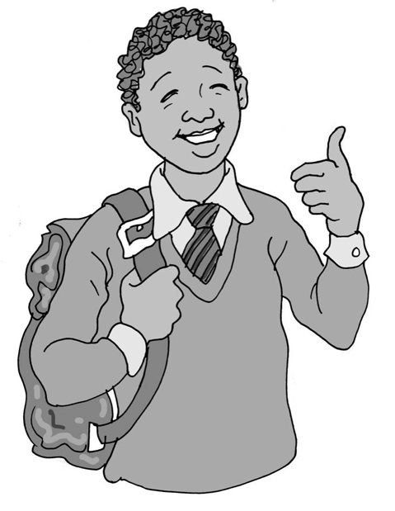
I am autistic

My name is .

I have autism.

Autism is the way my brain works. This is okay.

All people’s brains are different, some work one way, some work another way.

Every brain has things it can do well and things it is still learning.

Every brain has things it finds difficult to do.

People think in different ways and that is just fine.

It is good when other people understand that brains are different.

It is good if they know that autistic people need to do things in different ways, like learning at school, playing with toys at home or going to the shops.

Then it can be easier for everyone.

I am autistic. This is good.

I might find some things difficult, but I am also:
- able to notice lots of things other people might not notice
- able to concentrate really well on and .
- really good at .
- able to enjoy quiet and peaceful times
- able to run around, climb and jump on my trampoline*
- *

I am autistic and always will be. This is just fine.

I am me and that is great.

28
(*Put the child’s own interests in these bullet points.)

