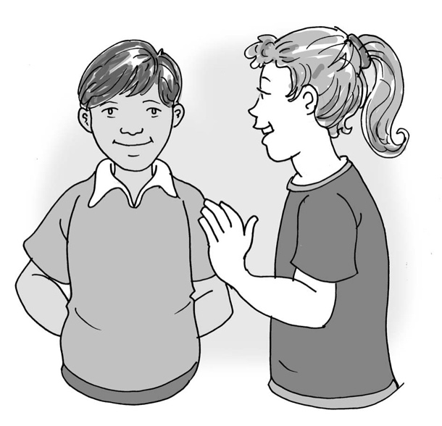
My friend is autistic

My name is .

I am in class.

My friends and I are all different, but sometimes we are similar too.

I have a friend called . She/he is autistic.

We both like:

We both can:

Being autistic means my friend’s* brain thinks in a different way to mine.
My friend and I are good at some things and find other things difficult. We are both learning new things every day, even if the way we learn is different.
This is okay.
I can help my autistic friend by understanding that it is okay to think in a different way. I can listen to her/him and join in the ideas she/he has when we play together.
I can ask her/him if I can learn what makes my friend feel happy and what makes my friend feel scared.
I can tell my teacher when my friend needs help.
I can remember that sometimes school is hard for me too. It is usual to feel upset when things are hard.
29

It is good to feel happy when you are doing something you enjoy. My friend and I love to laugh and enjoy things together.

We are brilliant!

(*Insert the child’s name here.)

