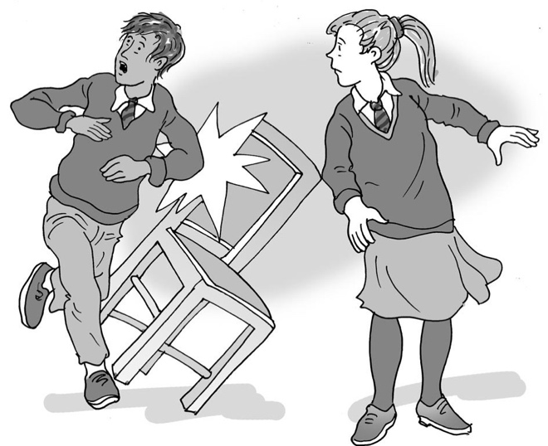
Sometimes things happen by accident

My name is .

I am in class.

There are lots of good things at school.

I like school when I do good work, play football with my friends, learn new things and feel proud of what I can do. I like it when it is a quiet day and I do my sensory activities.

My school can be a great place to be each day!

Sometimes things happen that are not so good. This is okay – they don’t have to spoil all the good things.

Sometimes people can feel very upset and cross if:
- a ball hits someone while we are playing football
- someone trips over a chair
- someone drops something on the floor
- someone bumps into someone else.

What else happens?
Sometimes things happen that are no one’s fault. We call these things ‘accidents’.
This is a good word to use. It means it was not done on purpose, and no one is to blame.

Sometimes accidents happen in the playground when lots of children are running around, or in football when someone kicks the ball and it goes a bit too high or someone runs in the way of the ball or another person. This is an accident.

Sometimes accidents happen in the classroom or hall when people are moving about, or something gets bumped as people walk about. This is an accident.

30

When an accident happens, I could say “Whoops” or “Excuse me”, “Sorry” or “That’s okay”.

If I feel hurt or angry when an accident happens to me, I can try to remember that it is no one’s fault.

I can ask my teacher or lunchtime supervisor to help me if I am hurt. They will take care of me and make sure I am okay. They can listen to why I feel cross and tell me how it was an accident. Then I could take a break, go and join in with my friends again or carry on with my activity.

This is great. I am learning to understand about accidents.

Well done me!

