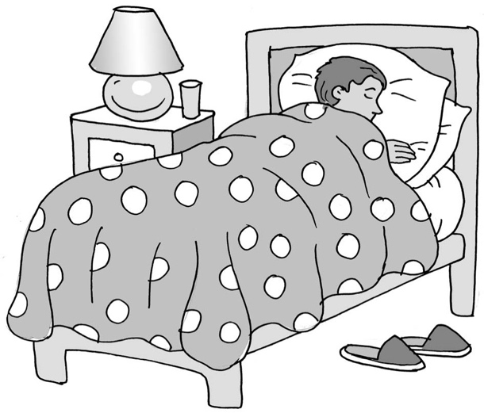
Sleep is good for my body and brain

My name is .

I live at home with .

At night time, people go to bed. They go to bed so that their bodies can have a chance to sleep.

Most people sleep for a long while, usually until the morning. Some people need to be woken up by an alarm clock or they would stay asleep!

Sleep is good for people. It is when their body and brain have a rest, and inside them their cells and organs get made new as they grow. This is good.

Brains might try to sort out all the information in them when we are asleep. Scientists think that’s what dreaming is. This is good.

Some people find it hard to get to sleep when they go to bed. Some people find it hard to stay asleep, and some people hardly ever sleep.

Not having sleep can make our bodies tired. Not having sleep can make our brains tired. This can make it hard to concentrate at school. It can make it hard to feel happy and calm.

I might need to try some new things to help me sleep. My parents might help me make a calm routine and make a timetable so that I know what I should do. This might have a time when I turn off my tablet/computer and then do some lovely sensory activities.

I might have to go to see a doctor who knows a lot about sleep and autism. This is okay, it can be very helpful.

It is good to learn how to sleep. It is good for my body and brain to have some rest.
I can try to help my parents find the best way that will help me.

Brilliant me.
54
Here is an article that might help parents learn more about sleep
www.autism-connect.org.uk/upload/pdf_files/1431002236_sleep%20and%20autism.pdf

