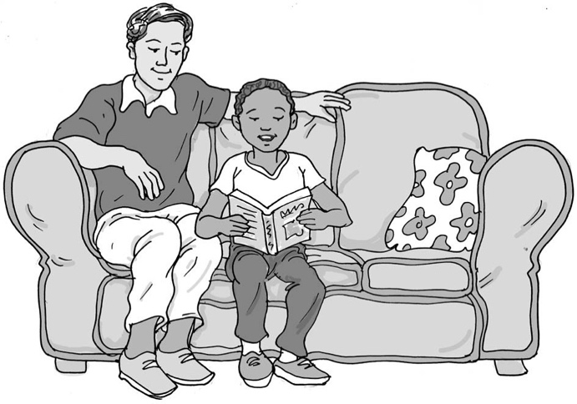
Reading my reading book
at home

My name is .

I am in class.

We learn to read by having a reading book and trying to work out what the words say using our phonics. When we can read the sentences in our reading book, they tell us some information about a subject or tell us a story. We usually practise reading at home too.

Sometimes I read my book myself. I can say the words out loud or inside my head.
This is okay.

Usually I read to mum or dad. They need to listen, and so they ask me to say the words I am reading out loud. This is good.

My mum and dad listen so that they know how to help me read better. If I can’t read a word or make a mistake, this is okay. It is a good idea to remember the reading rules:

Reading to my mum or dad:
- Read in a voice that my mum or dad can hear.
- If I don’t know a word, my mum or dad will say “Pause” and ask me to work it out. They can help me if I can’t do it on my own.
Pause means stop for a short time and start again after you have done something else (like work out a word or answer a question).

My teacher, mum or dad might ask me one or two questions about the subject or story to see if I have understood what I have read. This is good and helps me remember what the book is about. Brilliant.

I can be a great reader.

Well done me!
53

