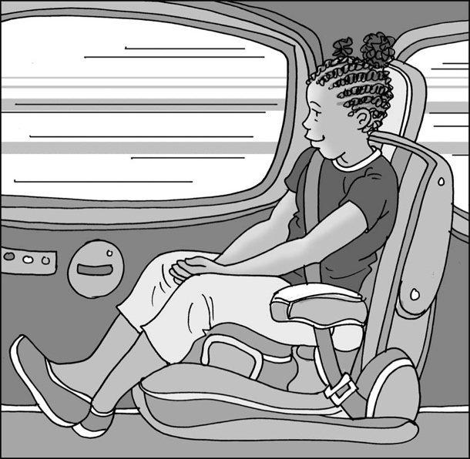
Staying safe
in the car

My name is .

I am in class.

When I am going somewhere, sometimes
I have to travel in the car.

My mum/dad usually drives the car because they have learned how to do it safely.
I have to sit in one of the passenger seats.

When I get into the car, I can sit in my seat and fasten the seatbelt around me.

Seatbelts were invented to keep everyone in the car safe. It is the law/rule of the country that everyone has to wear a seatbelt when they are travelling in a car.
This will keep my body safe. It is good to wear a seatbelt.

My mum/dad will tell me where we are going and how long it might take to get there.

I will have to sit in my seat with my seatbelt on until we get to where we are going and my mum/dad says “ you can get out now.”

It is good to be safe in the car. I will try to be quiet while my mum/dad is driving.
I can play on my touch screen tablet/listen to music/have my fidget toys/other while we travel to where we are going. Then they can concentrate on driving and we can travel safely to where we are going.

Mum or dad will be pleased with me if I try to stay quiet and keep my seatbelt on.

Well done me. Brilliant!
43

