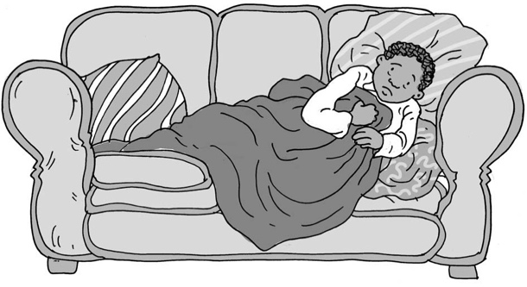
Being ill on a school day

My name is .

I am in class.

Usually I go to school on weekdays (Monday, Tuesday, Wednesday, Thursday, Friday).
At weekends (Saturday, Sunday) there is no school.

To go to school children need to be well. If they have a bad cold or feel ill, then it is a good idea to stay at home until they feel better. This helps the body make itself better.

Our bodies have lots of special cells that fight illness and work to make us better.
We can see it when we have a cut or a graze on our skin. First the cells make our blood clot to stop it bleeding, and then they make a scab over the wound to keep it
safe and clean while the cells mend the skin.

The same happens inside our bodies if we have a cold or feel sick or have another illness. The cells work to stop the illness getting worse and then make us better. Sometimes we have medicine that helps these cells do their work.

Medicine can be in tablets or a liquid we need to drink off a spoon. This is okay.
There are different ways to take medicine. We can take it in drinks or food so we
can’t see or taste it. It is good to take medicine so it can help our bodies get better.

Rest is good to help us get better too. That is why I won’t be going to school
today/for a few days. This helps my body get better too.

To help me rest I can .

After a while I will probably feel like my normal self again. Then I can go back to school on a school day.

Great news!

51
00

